Guidance Materials for Project Design Thinking & Planning – ‘Primary’
The materials in this document are ‘guidance’ materials. There is no requirement to complete them. We have provided:
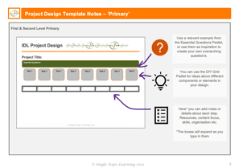
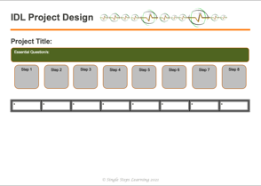
- A blank Design Template – with notes on how to complete it. This should provide an ‘at-a-glance’ overview of your project design.

- An example of a completed design – based on the ‘Iconic Structures of Europe’ project you will have seen in an iMovie. A more detailed design padlet can also be viewed at The Iconic Structure of Europe: Project Design
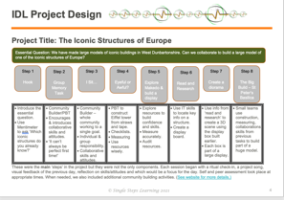

- A blank Design Thinking Guidance – this contains guidance questions intended to help clarify project details which will be summarised in the overview.
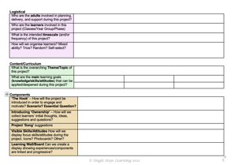

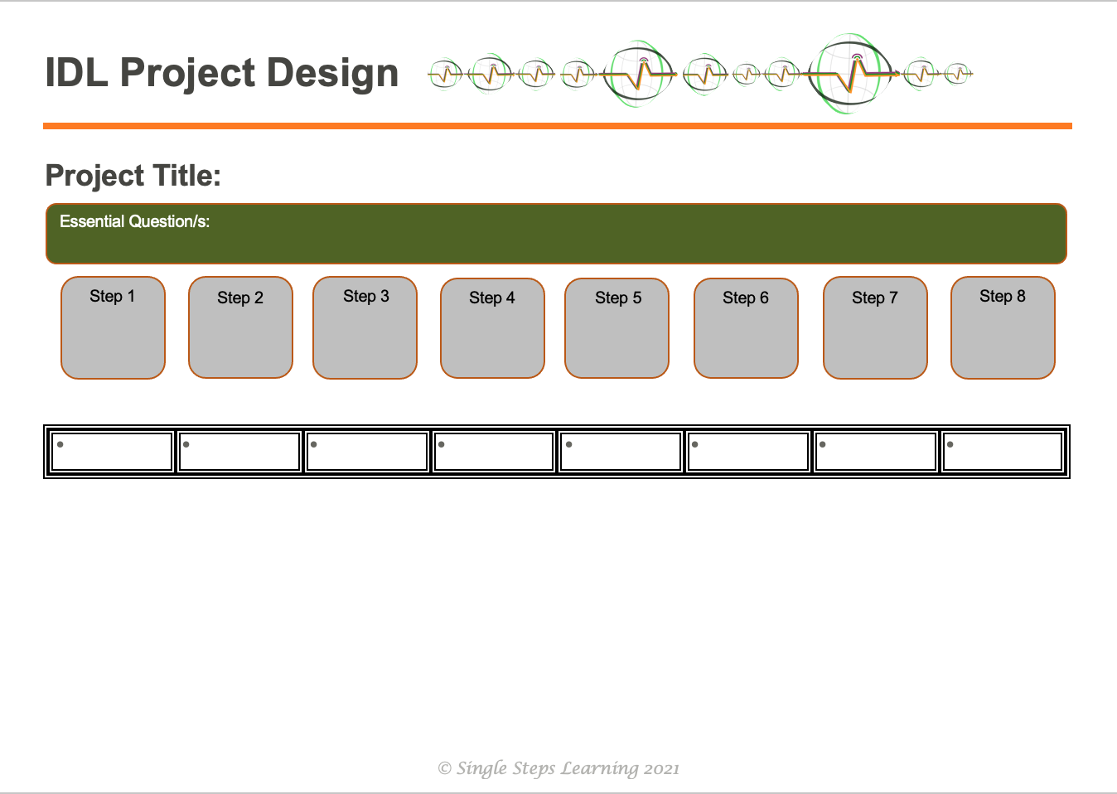
First & Second Level Primary
Here* you can add notes or details about each step. Resources, content focus, skills, organisation etc.
*The boxes will expand as you type in them
You can use the DIY Grid Padlet for ideas about different components or elements in your design.
Use a relevant example from the Essential Questions Padlet, or use them as inspiration to create your own overarching question/s.
Project Design Template Notes – ‘Primary’

IDL Project Design

Project Title:
Essential Question/s:

Step 7

Step 5

Step 6

Step 8

Step 4

Step 3

Step 2

Step 1

IDL Project Design

Project Title: The Iconic Structures of Europe
Essential Question: We have made large models of iconic buildings in West Dunbartonshire. Can we collaborate to build a large model of one of the iconic structures of Europe?

Step 5
Explore Makedo & build a display box
Step 8
The Big Build – St Peter’s Basilica
Step 6
Read and Research
Step 4
Eyeful or Awful?
Step 7
Create a diorama
Step 3
I Sit…
Step 1
Hook
Step 2
Group Memory Task

- Introduce the essential question.  - Use Mentimeter to ask ‘Which iconic structures do you already know?’ | - Community Builder/PBT  - Encourages & introduces collaborative skills and attitudes.  - ‘It can’t always be perfect first time!’ | - Community Builder – whole community working to a single goal.  - Individual & group responsibility.  - Collaborative skills and attitudes. | - PBT to construct Eiffel tower from straws and tape.  - Checklists.  - Measuring  - Use resources wisely. | - Explore resources to build confidence and skills.  - Measure accurately.  - Audit resources. | - Use IT skills to locate key info on a structure.  - Create a display board. | - Use info from ‘read and research’ to create a 3D scene using the display box built earlier.  - Each box is part of a large display. | - Small teams use construction, measuring, collaborations skills from previous tasks to build part of a huge model.

These were the main ‘steps’ in the project but they were not the only components. Each session began with a ritual check-in, a project song, visual feedback of the previous day, reflection on skills/attitudes and which would be a focus for the day. Self and peer assessment took place at appropriate times. When needed, we also included additional community building activities. (See website for more details.)
Logistical
Who are the adults involved in planning, delivery, and support during this project?
Who are the learners involved in this project (Classes/Year Group/Phase)
What is the intended timescale (and/or frequency) of this project?
How will we organise learners? Mixed ability? Trios? Random? Self-select?

Content/Curriculum
What is the overarching Theme/Topic of this project?
What are the main learning goals (knowledge/skills/attitudes) that can be applied/deepened during this project?

Components
‘The Hook’ – How will the project be introduced in order to engage and motivate? Scenario? Essential Question?
Introducing ‘Ownership’ – How will we collect learners’ initial thoughts, ideas, suggestions and questions?
Project ‘Song’ suggestions
Visible Skills/Attitudes How will we display focus skills/attitudes during the project. Icons? Photocards? Other?
Learning Wall/Board Can we create a display showing experiences/components are linked and progressive?

Linked Learning Experiences – Brainstorm  What will be the key linked learning experiences (IDL) during this project which will give opportunity to develop and apply the main learning goals (knowledge/skills/attitudes) from the Content/Curriculum and offer opportunity to develop collaborative skills for life, learning and work?  (There may also be a need for ‘direct teaching’ at different points to allow learners to acquire skills/knowledge they will need to develop and apply in future tasks)  See DIY Grid Padlet for ideas/suggestions. | Problem-Based Tasks: Which tasks will learners undertake to apply their knowledge, skills & attitudes – subject-specific and/or generic? | Community Building: Which community building games activities could we use to support collaborative skills/attitudes? | Reflection/Feedback: How will we provide reflection opportunities to reflect-connect-progress? Photo-feedback? Reflection circle? See/Hear board? Post-its? Learning logs?

Family Engagement: How will we involve families in their children’s learning? Wider sharing? | - iMovie  - Children as Teachers  - Learning Passport | - Blog/Website/Google Classroom  - Online engagement

THINK IT | TRY IT | FIX IT | SHARE IT
As leaders of learning we should be modelling this process for our learners. Our design ideas don’t always work out as we had hoped! Whatever the degree of success there is something to be learned!
Community Learning ~ Experiential Learning ~ Problem-Based Learning ~ Quality Learning ~ Reflective Learning

