Guidance Materials for Project Design Thinking & Planning – ‘Early Level’
The materials in this document are ‘guidance’ materials. There is no requirement to complete them. We have provided:
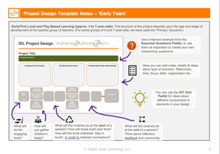
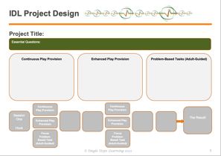
- A blank Design Template – with notes on how to complete it. This should provide an ‘at-a-glance’ overview of your project design.

- An example of a completed design – based on the ‘Pirates’ project you will have seen in an iMovie. A more detailed design padlet can also be viewed at Big Mack Needs Help: Project Design
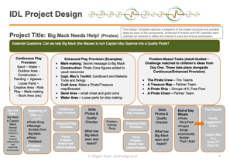

- A blank Design Thinking Guidance Notes– this contains guidance questions intended to help clarify project details which will be summarised in the overview.
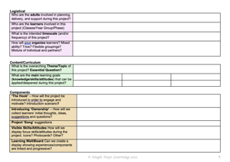

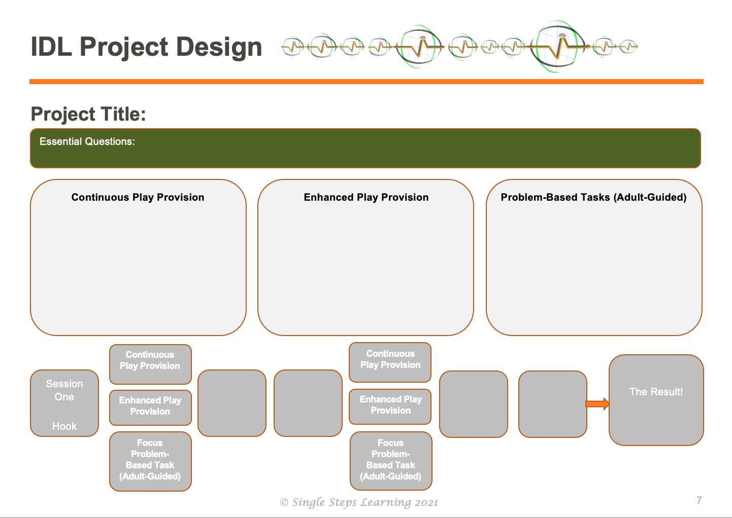
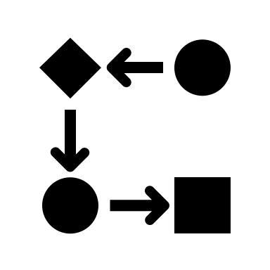
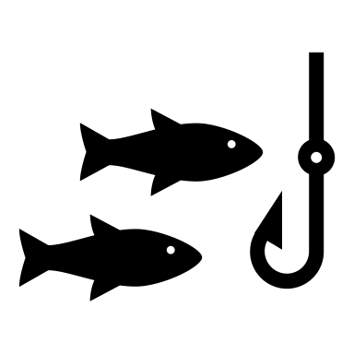
Early/First Level and Play-Based Learning (approx. 3 to 7-year-olds): The structure of the project depends upon the age and stage of development of the specific group of learners. (For some groups of 6 and 7-year-olds, we have used the ‘Primary’ structure.)
What will the routines be at the start of a session? How will these build over time? How will the hook character ‘stay in touch’, in order to maintain momentum?
What will the routines be at the end of a session? Think about reflection, feedback and community.
You can use the DIY Grid Padlet for ideas about different components or elements in your design.
Here you can add notes, details & ideas about type of provision. Resources, time, focus, skills, organisation etc.

Use a relevant example from the Essential Questions Padlet, or use them as inspiration to create your own overarching question/s.
How will you gather children’s ideas?
What will be the engaging hook?
Project Design Template Notes – ‘Early Level’

IDL Project Design

Project Title:
Essential Question/s:

Enhanced Play Provision

Problem-Based Tasks (Adult-Guided)

Continuous Play Provision

The Result!
Focus Problem-Based Task (Adult-Guided)
Enhanced Play Provision
Continuous Play Provision

Continuous Play Provision
Enhanced Play Provision
Focus Problem-Based Task (Adult-Guided)

Session One
Hook

IDL Project Design
This Design Template captures a snapshot of the project structure and possible ideas for each of the components. Enhanced Provision and PBT activities were changed as required to reflect the children’s input and ensure progression.

Project Title: Big Mack Needs Help! (Pirates)
Essential Questions: Can we help Big Mack (the Macaw) to turn Captain Mac Sparrow into a Quality Pirate?

Problem-Based Tasks (Adult-Guided – Challenge matched to children’s ideas from Day One. These take place alongside Continuous/Enhanced Provision)

- The Pirate Crew – Trio Teams
- A Treasure Map – Partner Team
- A Pirate Ship – Groups of 6, Free Flow
- A Pirate Chest – Partner Team

Continuous Play Provision
Sand ~ Water ~ Outdoor Area - Construction ~ Painting ~ Jigsaws - Loose Parts ~ Creative Area - Role Play ~ Mark-making – Book Area (etc)
M

Enhanced Play Provision (Examples)
- Mark-making: Secret message to Big Mack
- Construction: Pirate Crew figures added to usual resources
- Capt. Mac’s Toolkit: Cardboard and Makedo Tools and fixings
- Craft Area: Make a Pirate/Treasure map/Bracelet
- Sand Area – small chest and gold coins
- Water Area – Loose parts for ship making

Problem-Solving Song

Focus Problem-Based Task (Adult-Guided)
Enhanced Play Provision
Continuous Play Provision
Skills Photos & Quality Checker
What has Big Mack seen and heard?

Continuous Play Provision
Skills Photos & Quality Checker
What has Big Mack seen and heard?

The Result!
Family Engagement Event
Captain Mac is a QUALITY PIRATE!

End of Day Rituals
- Pirate Story/Fact
- Project Songs
- Community Builder: ‘Pobl I Bobl’
Day One Hook - Big Mack & Captain Mack Arrive! FOCUS: Children’s Ideas, building relationships and exploring environment

Beginning of Day (Day 2 onwards)
- Pirate Song
- Message Scroll(s) from Big Mack
- Photo Feedback
- Problem-Solving Song

Enhanced Play Provision

Focus Problem-Based Task (Adult-Guided)

Logistical
Who are the adults involved in planning, delivery, and support during this project?
Who are the learners involved in this project (Classes/Year Group/Phase)
What is the intended timescale (and/or frequency) of this project?
How will we organise learners? Mixed ability? Trios? Flexible groupings? Mixture of individual and partners?

Content/Curriculum
What is the overarching Theme/Topic of this project? Essential Question?
What are the main learning goals (knowledge/skills/attitudes) that can be applied/deepened during this project?

Components
‘The Hook’ – How will the project be introduced in order to engage and motivate? Introduction scenario?
Introducing ‘Ownership’ – How will we collect learners’ initial thoughts, ideas, suggestions and questions?
Project ‘Song’ suggestions
Visible Skills/Attitudes How will we display focus skills/attitudes during the project. Icons? Photocards? Other?
Learning Wall/Board Can we create a display showing experiences/components are linked and progressive?

Reflection/Feedback: How will we provide reflection opportunities to reflect-connect-progress? Photo-feedback? Reflection circle? ‘See/Hear’ board?
Community Building Which community building games activities could we use to support collaborative skills/attitudes?

Organisation of Experiences (Early/1st Level) – ‘Brainstorm’  The whole project scenario is rooted in high-level play provocation.  Continuous Provision: Those area open for play regardless of theme/project. Enhanced Provision: Areas ‘enhanced’ to provoke learning based on the theme e.g., gold coins in sand area for a pirate theme. Focused Tasks: Adult-guided play where group/s work together to solve a problem for a character, usually based on one of their ideas. | Problem-Based Tasks/Focused Tasks | Enhanced Provision | Continuous Provision

Family Engagement: How will we involve families in their children’s learning? | - iMovie  - Children as Teachers  - Learning Passport | - Blog/Website/Google Classroom  - Online engagement

THINK IT | TRY IT | FIX IT | SHARE IT
As leaders of learning we should be modelling this process for our learners. Our design ideas don’t always work out as we had hoped! Whatever the degree of success there is something to be learned!
Community Learning ~ Experiential Learning ~ Problem-Based Learning ~ Quality Learning ~ Reflective Learning

