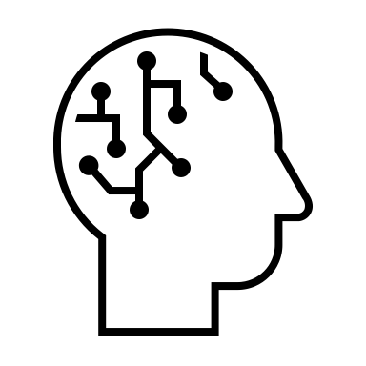
‘Back to the Future’

This morning, you have had a chance to reconnect with and reflect upon your achievements at Bedwas Infants. You have had the opportunity to identify and celebrate your personal highpoints from the 2020 Estyn Inspection Report. You have also had the opportunity to recognise and reaffirm those qualities (skills/attitudes/values) that have made you a successful community and will sustain you on the next phase of growth.

The global pandemic has challenged those in education to adapt to circumstances in ways that were unimaginable 12 months ago. This has meant the need to temporarily relinquish some ‘tried and tested’ practices and be creative and innovative.

In the hope that we are beginning to move closer to what we considered normality, you have been given an opportunity to reflect upon the events of the last year and how you can use the result of your reflections to have a positive impact on your learning community. Looking back in order to inform future action…or simply… ‘Back To The Future’.

Your Task

A padlet has been created for each ‘bubble’. Each padlet will consist of three columns.

KEEP (Brainstorm) – In this column, create a brainstorm list of innovative practices developed during the last year which you think are worth continuing unchanged. Also, consider things that you have been unable to do because of the pandemic and which you believe will be essential to return to as soon as you are able. (Remember, a brainstorm lists everything which you can think of no matter how trivial, obvious or contentious. No ideas should be discarded.)

CHANGE (Brainstorm) – In this column, create a brainstorm list of practices that occurred either during or prior to the pandemic which you feel, as a result of your experiences, would benefit from being modified/adapted in order to improve them. Explain any modifications you think should/could be made. (Again, a brainstorm lists ALL ideas).

GROW (Next Steps) – In this column you will have a chance to prioritise suggestions you have made in both your Keep and Change brainstorm lists. As a group, select 2 actions for immediate implementation/impact, 2 for medium-term and 1 for long-term.
You will share the information in this ‘Grow’ column with your colleagues.

Finally, as a bubble, select and prioritise 5 qualities that appeared on the ‘word cloud’. Find a household object to symbolise each of the qualities. Each person in your bubble is only allowed to supply one object. If you are in a group of 3 or 4, you must use one or both objects supplied by Andrew and Lynne. Your choice may be poignant or humorous…within the bounds of what is considered ‘good taste’ at Bedwas Infants! You will also share your choice of qualities and their symbols with the whole group. Your choice of household object must be something you can show to the camera. (Continues on Page 2)
Sharing Your Thinking

During the afternoon Zoom session, there will be time to share your ideas and suggestions with members from other bubbles and the whole community. It is intended that this will take place in two phases.

1. Your whole team will share your top five qualities and the five household objects chosen to symbolise them. This will take place with the whole community.

2. Each member of your bubble will meet with members from other bubbles (no more than four or five) in a break-out room and share the contents of Grow column. Therefore, all members of your bubble should be prepared to report and expand on the prioritised list in your Grow column. Each member will have up to 3 minutes to share. If possible, it would be helpful if they could visually share the padlet via the ‘share screen’ function. There is a share screen video tutorial on Element Six of the webpage. (If you are not familiar with this function you could practice the process in your bubble as part of the task time.) However, if you are unable to share your screen, a verbal explanation will do.

