A Packing Problem

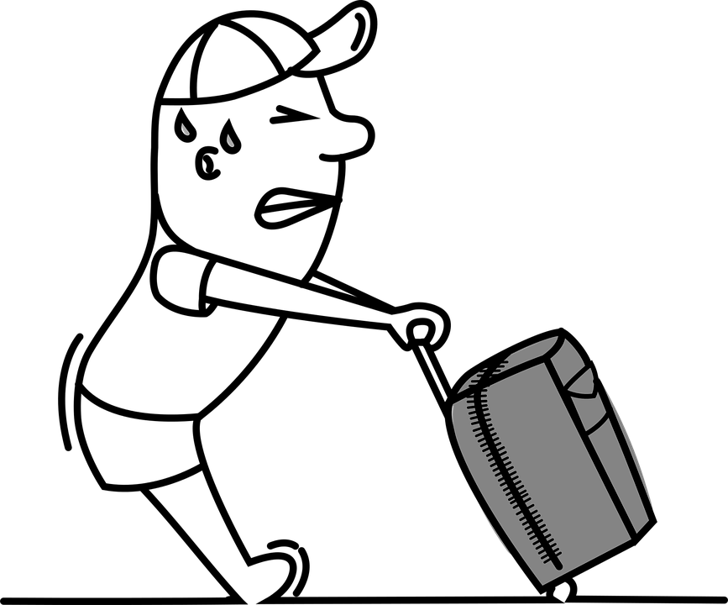

Did you know that there is a weight limit for your luggage on aeroplanes? We have checked the limit for our airline and it is 20 kilograms (kg) per person. If you go over the limit, you have to pay extra.

Lynne has a packing problem! She always packs too much! This time she has made a list of everything she is taking and given it to Andrew.

Andrew has managed to weigh one of each item but has not had time to work out how much everything weighs altogether.

Can you help Lynne and Andrew find out the total weight of Lynne’s luggage (including the suitcase)?

If it is more than 20kg, you will need to decide which items Lynne should leave behind?

A Packing Problem (Part 2)

A Weighty Problem

Now you have decided which items Lynne can take in her suitcase, we would like you to create a display board to help you to explain your decisions.

Your display board should be no bigger than A2 paper size. It should have a labelled picture of each item. The label should show the name of the item, how many Lynne is taking and the total weight of the item. The display board should have a title and contain the names of all your team members. Finally, your display board should show the grand total of the suitcase and all the items.

Here is a quality check list to help you remember everything:

- the display board is A2 paper size

- picture of every item
- each item is labelled
- each label shows the name, number and total weight of the item
- title
- names of team
- grand total weight of the suitcase and all the items.

- Wow! Can you add something to your display board to make it outstanding!

Write your Wow! ideas here…

